Name: Wong Chee Kin

Matrik No.: 279592

**Object-oriented example:**

Triangle Class

Scalene

Equilateral

Isosceles

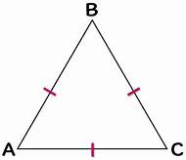v 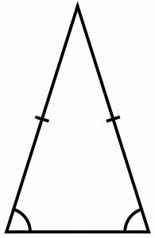 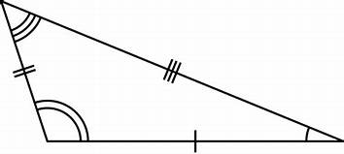

- 2 same internal angles

- 2 same equal length

- 3 different internal angles

- 3 non-equal length

- 3 same internal angles

- 3 same equal length

Car Class

Audi

Honda

Toyota

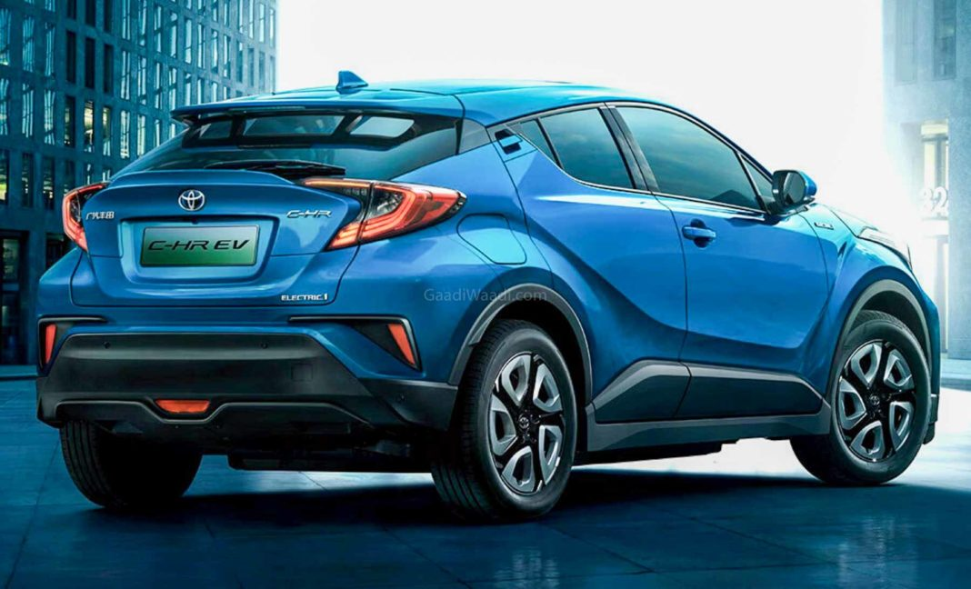 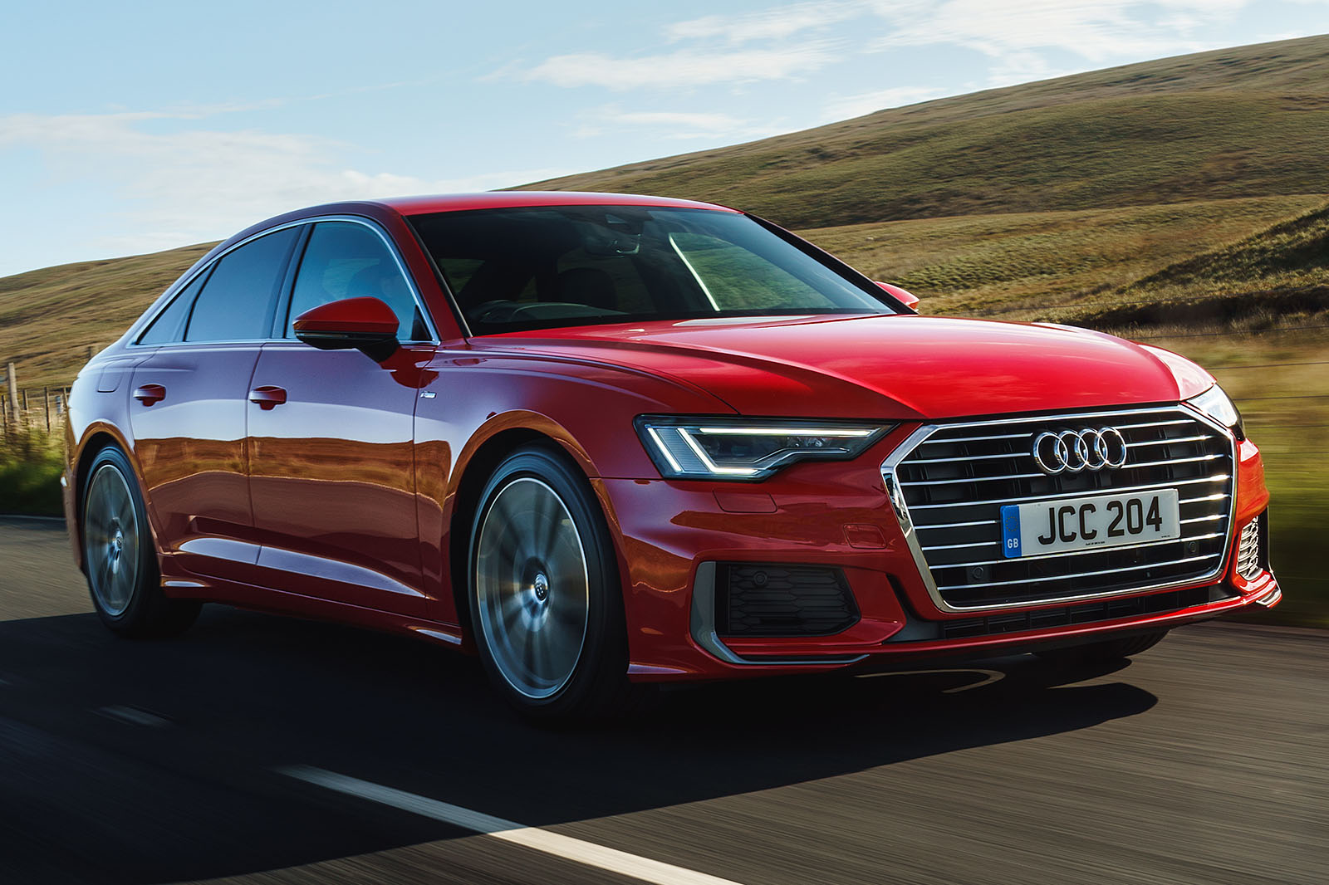 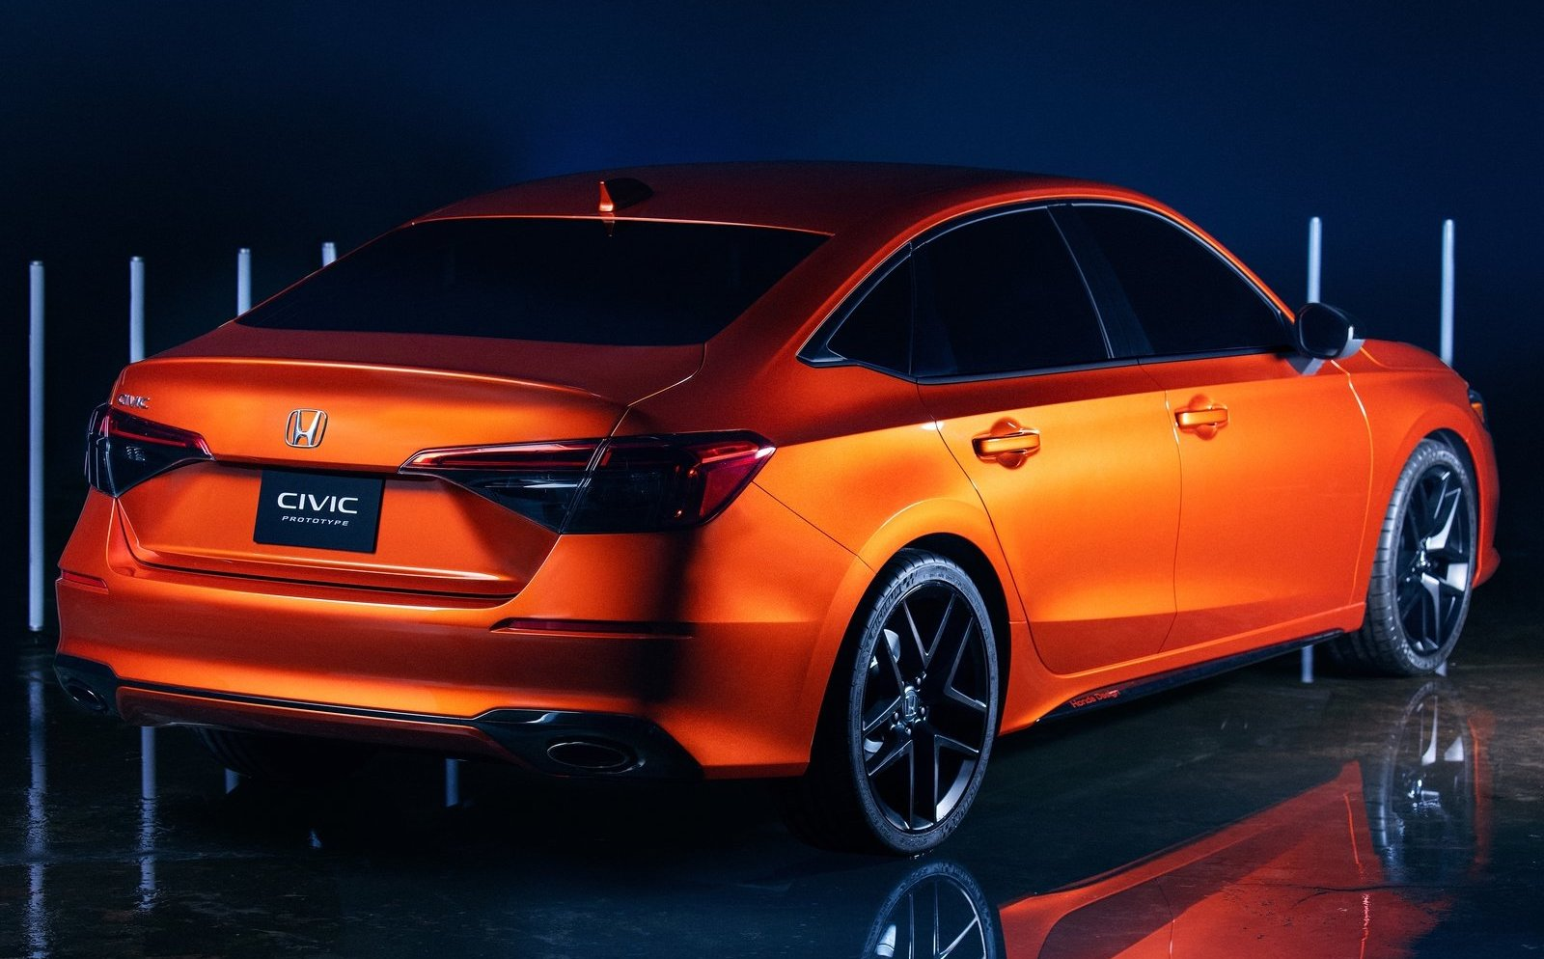

- Orange

- Honda Civic

- Medium size

- Fast

- Red

- Audi A6

- Medium size

- Fast

- Blue

- Toyota C-HR

- Large size

- Fast

Phone Class

Cell Phones

Corded Phones

 

- Long-distance communication

- Not convenient

- Lower cost

- 1 function

- Long-distance communication

- Convenient

- Higher cost

- More than 1 function

Shape Class

Rectangle

Triangle

Circle

- Length, Width

- Area = Length*Width

- Perimeter = a+b+c+d

- Green

- Length, Width

- Area = Length*Width/2

- Perimeter = a + b + c

- Yellow

- Radius

- Area = ℼr²

- Perimeter = 2ℼr

- Blue

Human Class

Female

Male

 

- Mom

- Daughter

- Student

- Employee

- Wife

- Dad

- Son

- Student

- Employee

- Husband